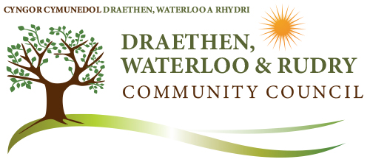
Community Council Email: clerk@dwrcouncil.co.uk
Website: www.dwrcouncil.co.uk
Temporary Clerk – Bob Campbell Bob.Campbell@riscatc.uk
or clerk2riscatc@gmail.com
Telephone 07779906517
Audit Notice
Financial year ending 31 March 2023
Date of announcement - 23 October 2023

- Publication of audited accounts for the year ended 31 March 2023.
- Regulation 15(5) of the Accounts and Audit (Wales) Regulations 2014 (as amended) requires that by 30 September 2023, DWR Community Council publish its accounting statements for the year ended 31 March 2023 together with any certificate, opinion, or report issued, given or made by the Auditor General.
- However, due to the demise of the former DWR CC in May 2023 the accounting statements for 2022/2023 in the form of an annual return had never been prepared, finalised nor published on the Council’s website. Thus the accounts were never published before the conclusion of the audit due on 30 September 2023 and the Auditor General has not yet been able to issue an audit opinion.
- Following Caerphilly County Borough Council‘s held elections in July 2023 a reformed DWR Community Council held its AGM and first Council meeting on 12 September 2023. Further discussions on progressing the 2022/2023 Audit Return will be held at its next set meeting date of Thursday 26 October 2023. The newly reformed Council is intending to reset its financial accounts and to appoint a new Community Clerk as soon as practically possible. The 2022/2023 Audit Return will be included in the new Clerk’s tasks.

For further information please contact :
Bob Campbell
DWR CC Temp Clerk
Email clerk2riscatc@gmail.com
Tel: 07779906517

The Auditor General can be contacted via:
Community Council Audits
Audit Wales
1 Capital Quarter
Tyndall Street
Cardiff
CF10 4BZ

